 **26 June 2015** **The Weekly Bulletin of Rotary Club of Kathmandu Mid-Town** **bc-46/6.015**

|  |
| --- |
|  |

District: 3292 Web:www.rotarymidtown.org.np Club Id: 26776

**JUNE IS THE ROTARY FELLOWSHIPS MONTH**

***June is designated Rotary Fellowships Month to recognize the importance of international fellowship and goodwill among Rotarians with similar recreational and vocational interests, promote increased participation***

***in fellowships, and increase understanding of this program.***

***The RI Board encourages these groups to celebrate Rotary Fellowships Month through projects, activities, and events.***

Club’s Weekly Meeting # 1284 on 19 June:

Extracts of the Minutes # 1284

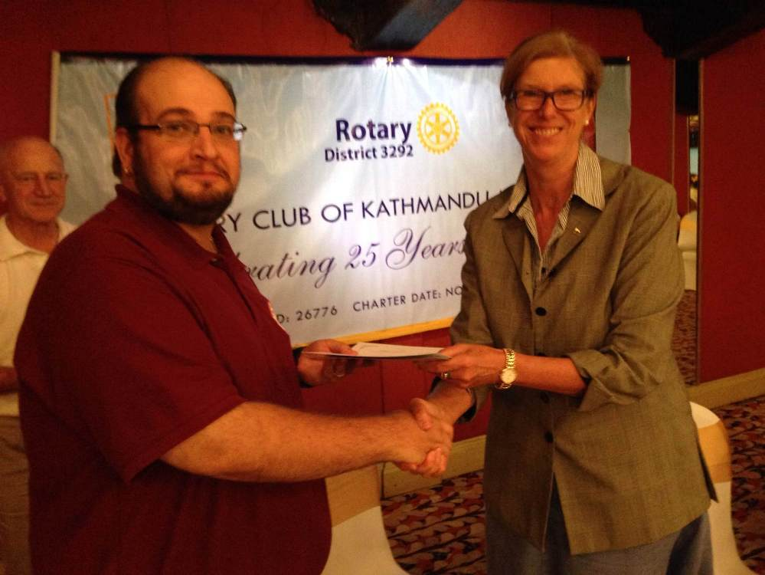

VP Lisa handing over certificate of appreciation to speaker Maj David Bennett

*Photo Courtesy:* Rtn Shyam R Thapaliya

“1. VP Lisa Choegyal called the meeting #1284 to order.

“3. VP Lisa welcomed members and guests including a visiting honorary Rotarian

(Nancy Smith) from The Mile High Club in Colorado, visiting Rotarian from the

Club of Wellington North (David Bennett), Bob Myers (Nepal Director for the

Salvation Army) and Her Excellency the Ambassador from Brazil Maria Teresa

Pessoa.

”7. Guest speakers Maj David Bennett National Coordinator Emergency Services

of the Salvation Army (SA) in New Zealand and Maj Bob Meyers who is

presently the SA's coordinator for Nepal. These two speakers gave a short

background to the Salvation Army and the work they are presently doing in

Nepal. Rtn Dr Buddha gave the vote of thanks.

”8. Information sharing:

> RC Kathmandu Mid-Town has signed an MOU with District 3292 to build

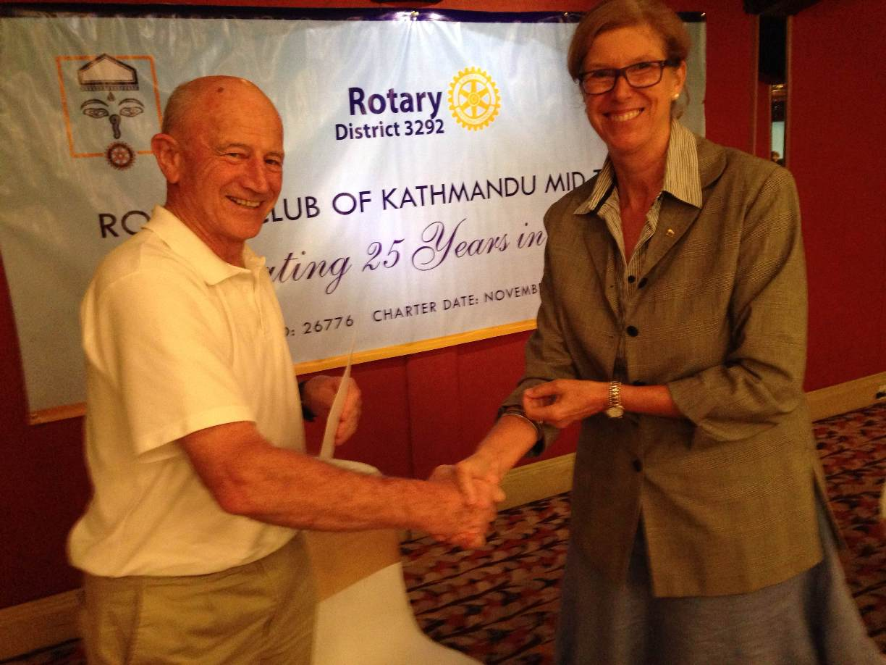

Maj Bob Meyers receiving certificate

*Photo Courtesy:* Rtn Shyam R Thapaliya

temporary shelters for earthquake victims: Mid-Town will build 100 shelters

and the District will support by matching 100 shelters

> TRF Chair PP Komal reported that he had been in communication with the

folks from the RC DC Capitol Hill and DC Rotary clubs and Ashley Haeger

of NTTI who have proposed the teacher training proposal for Humla.

PP Komal has had much discussion with them and they have submitted

clarification to his queries. RC KTM Mid-Town has decided to embark on the

GG with this Club and the primary contact for Mid-Town will be Rtn KB

Rokaya and the secondary contact will be PP Kul Chandra Gautam;

> TRF Chair PP Komal reported that the Board decided that the proposed

GG with RC Ellon ahould go ahead with First Steps Himalaya in Sindu-

palchowk. Primary Contact will be Lisa Choegyal;

> All concerned please submit MG reports so that we can go ahead with this

year's Global Grants. The outstanding reports are: MG #77952- Early Childhood Development Program - Schools in Sindhupalchok RC Oldmeldrum, Scotland. PP Ajay please prepare the needed report. RID-1010 and MG # 78232- Samapati Water Project; PP Gopal please prepare the needed report;

> PP Mani reiterated that the project need not be completed for the MG reports to be written but that it is important to submit an interim report otherwise it will not be possible for Mid-Town to apply for the above mentioned Global Grants;

> Rtn Pabitra summarized the latest on the biogas project MG MG # 79679- Bio Gas Project, Parsauni, Nawalparashi which is being funded by RC of Borken, Germany RID-1870 (contact Rtn Remy Einhaus). He will circulate the report as soon as it is available;

> Rtn Navyo informed that RC Villoresi Milano is interested in continuing their support in Tistung;

> The Board 2014-15 and the Club have now approved the membership of Ms Judith Amtzis. VP Lisa welcomed Judith to the Club.

“9. Statistics of the meeting: Members present: 20”

# Weekly Meetings and Programs :

|  |  |  |
| --- | --- | --- |
| Date | Program/ Speaker | Topic of Presentation |
| 26 June | 26th Installation of the Club | President Kul to hand over the charge of the Club to PE Paras |
|  |  |  |

Weekly Meeting on Friday, 26 June:

**Rotary Club of Kathmandu Mid-Town’s 26th** **Installation**

**Day / Date : Friday / 26 June**

**Venue : Hotel de l'Annapurna**

**Meeting starts at 18:00 hrs, Dinner 19:30 hrs onwards**

**No registration fee for member; spouse or friend pays Rs 2,000 each**

*Please note: there will be no regular weekly meeting on 26 June Friday morning.*

**ROTARY FELLOWSHIP**

Rotary Fellowships are independent groups of Rotarians, their spouses, and Rotaractors who share a common passion. Being part of a fellowship is a fun way to make friends from around the world.

What Fellowships Are Available?

Fellowship activities vary widely. Members come together around hobbies or interests such as cricket or jazz, or vocations such as writing or medicine. Some groups are purely social while others use their fellowship for service projects. View a list of Rotary Fellowships.

How Do I Join A Fellowship?

You can also contact a fellowship directly by using the information listed in the [Rotary Fellowships directory](https://www.rotary.org/myrotary/en/document/rotary-fellowships-directory). Or search our [discussion groups](https://www.rotary.org/myrotary/en/exchange-ideas/groups) to find Rotary and Rotaract members with similar interests.

How Do I Start A Fellowship?

Chances are if you have a strong interest in something, there are others in the Rotary family who share it. Forming a fellowship starts with finding members for your group. Here’s how you can start:

- [Join a discussion group](https://www.rotary.org/myrotary/en/exchange-ideas/groups/start) or start a new one. It's a great way to share your interest with other members.

- Use Rotary’s presence on [Facebook](https://www.facebook.com/rotary), [Twitter](https://twitter.com/rotary) and [LinkedIn](http://www.linkedin.com/groups/Official-Rotary-International-Group-858557/about) to promote your idea.

- Ask your district Rotary Fellowships chair for assistance. Reach out to district Rotary Fellowships chairs in other

countries to build membership. Ask for contact information at [rotaryfellowships@rotary.org](mailto:rotaryfellowships@rotary.org).

- Be sure you meet the criteria for a fellowship and apply for official recognition.

See the [Rotary Fellowships Handbook](https://www.rotary.org/myrotary/en/document/rotary-fellowships-handbook) for details.

**21 June : International Day of Yoga**

21 June 2015 is declared as the International Yoga Day by the United Nations General Assembly on December 11, 2014. Yoga, a physical, mental and spiritual practice having its origin over 6000 years ago in India, aims to integrate the body and the mind. It embodies unity of mind and body; thought and action; restraint and fulfilment; harmony between man and nature; a holistic approach to health and well-being. It is not about exercise but to discover the sense of oneness within yourself, the world and the nature. The declaration of this day came after the call for the adoption of 21 June as International Day of Yoga by PM Narendra Modi during his address to UN General Assembly on September 27, 2014.

**Designer Babies – a Reality?**

Improvements in genetics are causing designer babies to near '100 per cent efficiency' in trials using mice, a leading scientist has warned. Dr Tony Perry, a geneticist at the University of Bath, said that society needed to be prepared for the day parents can choose certain traits in their children. The warning follows a breakthrough in April in which scientists were able to cure a genetic liver disease in living, adult mice using the Crispr-Cas9 gene editing technique.   
The Crispr technology precisely changes target parts of genetic code and could be used to create designer babies. 'We used a pair of molecular scissors and a molecular sat nav that tells the scissors where to cut,' Dr Perry said.

The DNA cut – known as a double strand break – closely mimics the kinds of mutations that occur naturally, for instance after chronic sun exposure.

For decades, designer babies - modified for health, beauty and intelligence - have been the reserve of science fiction. But Crispr technology could change all that. It may soon find its way into fertility treatments.

He says it is up to society, and not just scientists, to look at the implications and decide whether the technology is worth the risk. Beyond simply addressing health concerns, many are worried that the technology can be used to give babies desirable traits.. Nuffield Council on Bioethics director, Hugh Whittall, said the issue raises questions of social justice, with the technique only available to the rich. The trend towards services such as this has already begun.

In theory, the technology could be used to screen potential babies for traits other than diseases. It would also fall outside rules used to regulate embryo testing and screening.

Professor Lovell-Badge from the UK Research Medical Council said that despite concerns, the issue is something that needs to start being debated.

'There has been a blanket ban on germ-line therapy, so there needs to be a debate about that and some rational thought rather than knee-jerk reactions that, "No you can't possibly do that."

Read more: [http://www.dailymail.co.uk/sciencetech/article-2917060/Designer-babies](http://www.dailymail.co.uk/sciencetech/article-2917060/Designer-babies%20%20)

Travel / Tourism

**

“Travel and change of place impart new vigor to the mind”

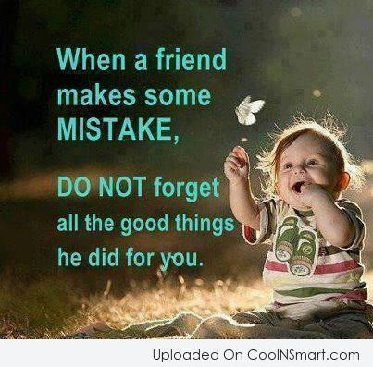

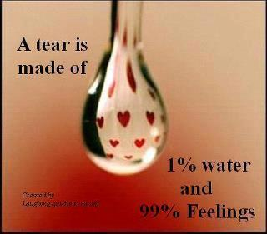

**A THOUGHT FOR TODAY:**

**[If your foot slips, you suffer a fracture;](http://www.brainyquote.com/quotes/quotes/b/baruchspin101666.html" \o "view quote)**

**[if your tongue slips, you fracture someone's faith or joy.](http://www.brainyquote.com/quotes/quotes/b/baruchspin101666.html" \o "view quote)**

**[That fracture can never be set right; that wound will fester forever.](http://www.brainyquote.com/quotes/quotes/b/baruchspin101666.html" \o "view quote)**

**[Therefore, use your tongue with great care.](http://www.brainyquote.com/quotes/quotes/b/baruchspin101666.html" \o "view quote)**

**[Always speak softly and sweetly, and only as much as is necessary!](http://www.brainyquote.com/quotes/quotes/b/baruchspin101666.html" \o "view quote)**

## ENJOY EACH DAY

## 

** **

On Lighter Side:

**Smart Diagnosis!**

A young doctor had moved out to a small community to replace a doctor who was retiring.

The older doctor suggested that the young one accompany him on his rounds,

so the community could become used to a new doctor.

At the first house a woman complains, "I've been a little sick to my stomach."

The older doctor says, "Well, you've probably been overdoing the fresh fruit.

Why not cut back on the amount you've been eating and see if that does the trick?`

As they left, the younger man said, "You didn't even examine that woman?

How'd you come to the diagnosis so quickly?" "I didn't have to.

You noticed I dropped my stethoscope on the floor in there?

When I bent over to pick it up, I noticed a half dozen banana peels in the trash.

That was what probably was making her sick.

"Huh," the younger doctor said. "Pretty clever. I think I'll try that at the next house."

Arriving at the next house, they spent several minutes talking with a younger woman. She complained that she just didn't have the energy she once did and said, "I'm feeling terribly run down lately. 'You've probably been doing too much work for the Church," the younger doctor told her. "Perhaps you should cut back a bit and see if that helps."

As they left, the elder doctor said, "I know that woman well.

Your diagnosis is almost certainly correct, but how did you arrive at it?

"I did what you did at the last house.

I dropped my stethoscope and when I bent down to retrieve it, I noticed the preacher under the bed."

**Life is like that!**





.

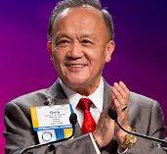

I thank all of you for the opportunity to serve as your president this year, and for the hard

work and dedication of our volunteer leadership and our staff members. I came to them

with high expectations – and they delivered.

**RI President GARY C.K. HUANG**

## 26 June 2015 The Weekly Bulletin of Rotary Club of Kathmandu Mid-Town bc-46/6.015

*******

**Wishing You All a Very Happy New Rotary Year : 2015-016**

